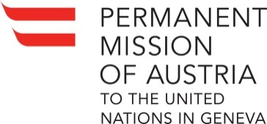 Check against delivery

UN Human Rights Council
27th Session of the UPR Working Group
Review South Africa, 10th May 2017

Statement by AUSTRIA

Austria welcomes the delegation of South Africa to the UPR and thanks for the insightful presentation of the national report.
We commend the government of South Africa for having taken a number of positive steps since its last review. These include the ratification of the International Covenant on Economic, Social and Cultural Rights, the adoption of the Prevention and Combatting of Torture of Persons Act and the launching of a public consultation on the Prevention and Combating of Hate Crimes and Hate Speech Bill.
Austria remains however concerned about various human rights issues including the excessive use of force by security forces including in prisons and detention centres, growing numbers of corruption cases within the police as well as violence against women.
Austria would therefore like to offer the following recommendations:
- Increase efforts in guaranteeing women's access to justice, protection and other remedies and put in place stronger mechanisms to protect women and girls against gender-based violence and provide redress to victims.

- Take further action regarding oversight and training for security forces in human rights, including to address violence related to rising hatred against foreigners, and making sure security forces carrying out law enforcement duties comply with the UN Code of Conduct for Law Enforcement Officials and the UN Basic Principles on the Use of Force and Firearms by Law Enforcement Officials.
- Ratify protocols the country has committed to ratifying including the OP-CAT.

